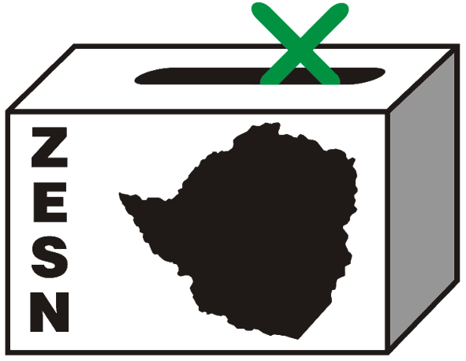

ZESN’s Statement on the state of the voters roll in Zimbabwe

16 December 2010-Harare- Zimbabwe Election Support Network welcomes the statement expressed by the Registrar-General on the 14th of December 2010 on ZBC TV. The Registrar-General noted that the voters roll is in shambles, an aspect that ZESN has over the years emphasized. ZESN notes that a clean voters’ roll will go a long way in increasing the credibility of electoral processes in Zimbabwe.

ZESN appreciates the intention to finally act on the voters roll. Findings from the voters roll observation recently conducted by ZESN revealed significant flaws with the voters roll when tested for currency, completeness and accuracy. The research revealed that 27 per cent of voters in the voters roll are deceased, 41 per cent of voters do not live at the address listed in the voters roll and that only 18 per cent of registered voters are youths (18-30). Research findings also showed that proof of residency requirements for urban populations constituted an obstacle in voter registration.

While ZESN welcomes the intention to cleanse the voters roll, we urge the Registrar-General to ensure that the process is under the control of the Zimbabwe Electoral Commission which has the legal mandate for electoral processes in Zimbabwe. ZESN observes the close link that exists between voter registration and civic registry but still believes that the mandate for voter registration should fully fall under the Zimbabwe Electoral Commission (ZEC). ZESN believes that total control of the voters roll by ZEC will ensure greater accountability on the state of the voters roll.

The voter registration and voters’ roll clean-up processes need to be transparent, inclusive and allow those who are eligible to vote to be registered and those who are not eligible such as deceased people to be removed from the voters roll. ZESN encourages the commission to engage in voter education related to voter registration, display, make accessible the voters roll to the public to ensure transparency and enhance confidence in the electorate.

An accurate, complete and current voters’ roll will ensure that all eligible Zimbabweans are able to exercise their democratic right to vote in elections more so as we approach the referendum and general elections in the near future. ZESN expects that disclosure of the process will ensure that the authorities’ plan for the millions of Zimbabweans working outside is revealed and interrogated openly.
_____________________________________________________________________________________
PROMOTING DEMOCRATIC ELECTIONS IN ZIMBABWE
FOR COMMENTS AND FURTHER DETAILS CONTACT
Zimbabwe Election Support Network
+263 (04) 791443, 798193, 791803, 250736
zesn@africaonline.co.zw / info@zesn.org.zw or visit www.zesn.org.zw

