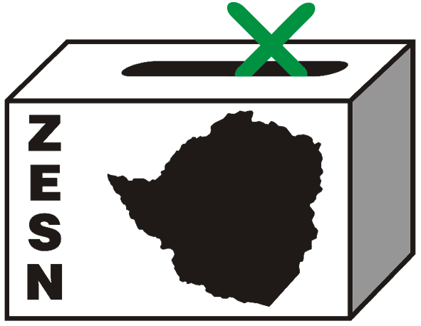

08. April 8, 2010
STATEMENT ON THE BARRING OF ZESN FROM CONDUCTING A WORKSHOP IN MBIRE
The constitution reform process taking place in the country has presented an opportunity for Zimbabweans to craft their own constitution which reflects their principles, values and desires as a people. The process has been deemed “a people-driven constitution” meaning that it is for the people, by the people and with the people. Therefore, every citizen has the right to participate and express their views and desires for consideration in the drafting of the new constitution. ZESN upon recognizing and appreciating this unique opportunity, embarked on a public outreach campaign to sensitize the communities on the various options available for electoral reforms, exploring the pros and cons of each. The issues of discussion included the constitution-making process, electoral systems, and electoral management bodies, systems of governance as well as encouraging peace and tolerance in the process. The motive was to equip the electorate and engage them in discussions of the relevant issues so that they can make meaningful contributions from an informed basis when the public consultations began.
It is in this view that ZESN organized 2 workshops in Mbire scheduled for the 7th and 8th of April 2010. A pre-visit to the area was conducted on the 9th of March in preparation of the workshop where the ZESN team met with the local District Administrator who appreciated the initiative and granted ZESN permission to conduct the workshop and police clearance was also granted.
On the 7Th of April however, the DA allegedly acting under the authority and instruction of the Governor and the PA informed the ZESN team that the workshops could no longer proceed as they felt that the community did not need the deliberations and information from the workshop. They questioned the need for reforms and peace buildings as there were no incidents of violence in the area after branding ZESN as an animal that they did not want to see in the area. Furthermore, threats of unspecified action were issued to those who wished to participate or get near the workshop venue.
This act reveals the levels of intolerance still prevailing in some parts of the country as this is gross violation of democratic principles and processes as well as the letter and spirit of the GPA. ZESN regards this incident as repressive and manipulative since the community was denied their right to information regarding such pertinent issues as the constitution making process in which everyone has the right to information. It does not condone such undemocratic practices as they stifle efforts to encourage meaningful participation and contribution in the constitution-making process.
For comments and further information, please contact
Zimbabwe Election Support Network
Tel: 04-250 730/791 443 Fax: 04-250 735
Email: zesn@africaonline.co.zw or info@zesn.org.zw
Promoting democratic elections in Zimbabwe

