ZIMBABWE ELECTION SUPPORT NETWORK

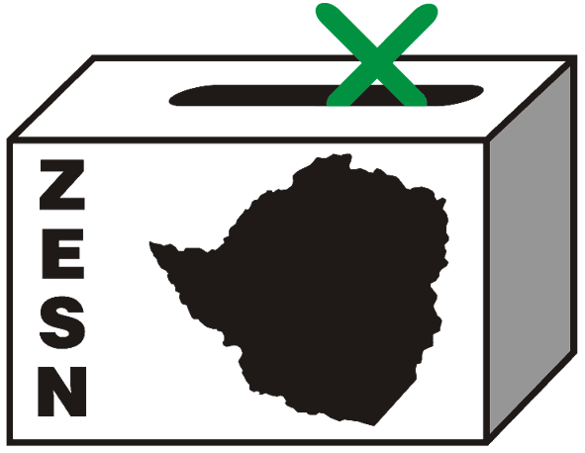

PRESS STATEMENT

ZESN STATEMENT ON JESTINA MUKOKO

Harare – 29 September 2009 - The Zimbabwe Election Support Network congratulates Zimbabwe Peace Project Director, ZESN Board Member, Jestina Mukoko for being granted permanent stay of criminal proceedings by the Supreme Court on 28 September 2009. Though it is distressing to note that this judgement only comes nine months after Mukoko, a defenceless woman was forcibly taken by 15 armed men from her home on 3 December 2008, a time when the world in general and Zimbabwe in particular was commemorating 16 Days of Gender Activism and was forced into an incommunicado detention, subsequent imprisonment and remand out of custody.

With heavy hearts we however appreciate the judgement and commend the judiciary in this case for complying with the oath of their office and their constitutionally enshrined mandate to protect the fundamental rights and freedoms of all citizens of Zimbabwe without fear or favour. ZESN hopes that similar cases that are still pending in the courts of law will be dealt with fairly and expeditiously, and that justice would take course.

We urge the government of Zimbabwe to uphold by the principles that the country is a signatory and part to which includes the African Charter on Human and People’s Rights, the International Covenant on Civil and Political Rights which recognizes the protection to life and physical integrity of a person and detest against the arbitrary depravation if liberty of any individual in Zimbabwe. We reiterate our concern over authorities that maintain law and order and urge them to be professional, respect and protect individual human rights.

ZESN is proud to be associated with Mukoko and ZPP and wishes them more success in their pursuit for human rights, justice, peace, good governance and democracy in Zimbabwe. ZESN also congratulates the legal team that represented Mukoko, for their patience and determination in search for justice.

PROMOTING DEMOCRATIC ELECTIONS IN ZIMBABWE

FOR COMMENTS AND FURTHER DETAILS CONTACT
Zimbabwe Election Support Network
+263 (04) 791803/798193/791443
zesn@africaonline.co.zw / info@zen.org.zw or visit www.zesn.org.zw

