ZIMBABWE ELECTION SUPPORT NETWORK

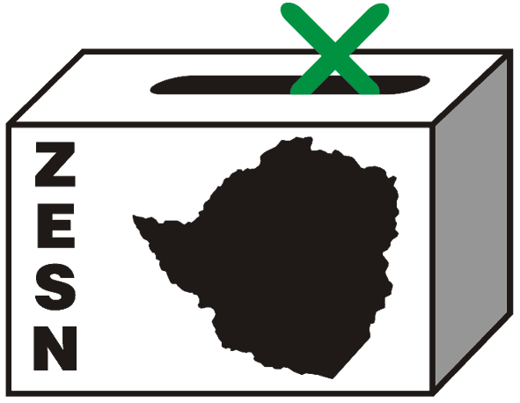

PRESS STATEMENT

ZESN sets priority areas for electoral reform ahead of by-elections and referendum

Harare – 16 September 2009 - Recognising that the current political dispensation presents unique opportunities to reform key electoral institutions and democratize our electoral legal framework, the Zimbabwe Electoral Support Network (ZESN) has set priority areas for electoral reforms that should be put in place prior to the holding of impending by-elections and before the referendum on the draft new constitution. By elections are due in a number of constituencies after the moratorium for by-elections which was set by the three principles in the GNU expired on 15 September 2009.

ZESN has over the period proposed a series of electoral reforms to the electoral laws of Zimbabwe and it is from these proposals that the Network has drawn and prioritized reforms that need to be put in place before any by-elections and referendum if the country is move towards holding legitimate, democratic, free and fair elections.

ZESN notes the urgent need for a truly independent, non-partisan, transparent, accountable, credible and efficient election management body appointed in an open and inclusive process. It is vitally important that this body consists of persons in whom the public have confidence that they will perform their duties conscientiously, independently and without political bias. ZESN still believes that the way in which this Commission is constituted is not satisfactory, in particular the manner in which the chairperson is appointed and the perceived political affiliation of some of its secretariat staff.

ZESN has repeatedly pointed out that the current voters’ roll is highly inaccurate and needs either to be completely overhauled or a new voters’ roll should be compiled. Ideally no by-election should be held until the Commission has conducted a full audit of the constituency roll in question to check its accuracy. ZESN has further recommended that the function of voter registration be removed from the Registrar-General of Voters and taken over by the Commission.

The processes of counting and tabulation of results must be done efficiently and expeditiously after polling has taken place and there must be no unreasonable delay in announcing the results. The counting and collation processes should be done in the presence of candidates or their polling agents.

When entire party structures are focused on a single by-election there is a grave risk that even more violence and intimidation may be brought to bear. It is imperative that concerted steps be taken to ensure that by-elections and referendum are peaceful.

ZESN is distressed by the highly restrictive current law relating to observers. Independent observation of elections is a vital part of fair electoral process and lends credibility to the process. Local and international observers should be free to observe all by-elections. They should be free to observe during the lead up period to the by-election and referendum and to observe the voting process and the collation and announcement of results and the period following the announcement of results.

Furthermore the whole media arena should be opened up so that there can be media diversity in both print and broadcasting prior to by-elections. The Zimbabwe Broadcasting Corporation (ZBC) should also be transformed from a highly partisan broadcaster into a genuinely public broadcaster that will cover elections on a fair and balanced basis. The repressive media laws that exist currently must be completely overhauled, though such changes on media laws are unlikely to be effected in the short time available. ZESN is therefore calling the Commission to use the legal powers already incorporated into the Electoral Act to ensure fair coverage of elections and avoidance of hate speech.

The power of the Electoral Commission to make regulations in respect of elections should be more limited and be made more specific and the regulations that they are still empowered to make should not be subject to approval by the Justice Minister. The President should not be able to use the Presidential Powers (Temporary Measures) Act to change any of the electoral rules.

ZESN is also recommending that in the upcoming referendum it would seem that serious consideration should be given to changing the law to allow people to vote at any polling station throughout the country on the basis of their National Identity Cards rather than in constituencies on the basis of proof of registration as voters.

Concerning the issue of voter education and information voters need to decide whether or not they will vote in favour of the draft new Constitution, so it is vital that they be made aware of the contents of the draft constitution. This requires that the draft be made available and circulated for scrutiny throughout the country. But even if the draft is freely available it is unlikely that the entire document will be read and studied by all literate people and obviously illiterate people will be unable to read it.

ZESN has proposed that that as most members of the Diaspora are in South Africa and the United Kingdom, arrangements should be made for them to cast their votes at the Zimbabwean embassies in Pretoria and London, and perhaps in other centres as well. ZESN proposes that the law be changed to allow the Electoral Commission to establish this system with the necessary safeguards to prevent fraudulent manipulation of the system. ZESN therefore maintains this reform should be put in place prior to the referendum.

Cognisant of the fact that constitutional, legislative and administrative reform alone does not guarantee an environment conducive for free and fair elections ZESN is committed to continue advocating for the implementation of reforms that will help to ensure that by-elections, the referendum and ultimately that the next general election will be as free and fair as possible. ZESN therefore calls for political will to be exercised in order to ensure that beyond credible and acceptable elections, a culture of entrenched democratic values is consolidated in Zimbabwe. End//

PROMOTING DEMOCRATIC ELECTIONS IN ZIMBABWE

FOR COMMENTS AND FURTHER DETAILS CONTACT
Zimbabwe Election Support Network
+263 (04) 791443, 798193, 791803
zesn@africaonline.co.zw / info@zesn.org.zw or visit www.zesn.org.zw

