ZIMBABWE ELECTION SUPPORT NETWORK

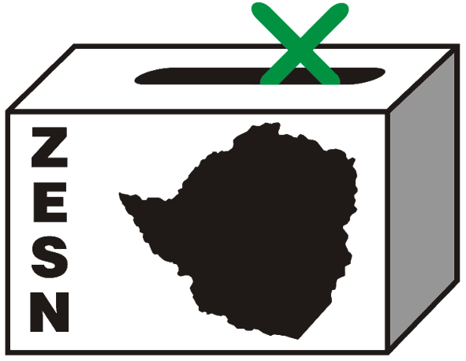

PRESS STATEMENT

ZESN STATEMENT ON ABDUCTION AND CONTINUED SECRET DETENTION OF JESTINA MUKOKO

Harare - 6 December 2008 - The Zimbabwe Election Support Network (ZESN), learnt with deep shock and dismay the violent abduction and secret detention of the ZPP Executive Director and ZESN Board member Ms Jestina Mukoko. ZESN joins the long list of organisations and individuals which have expressed their grave concern and condemnation of the abduction of Ms Mukoko.

It is distressing to note that Ms Mukoko, a defenceless woman was forcibly taken by 15 armed men from her home in the early hours of the morning of 3 December 2008, a time when the world in general and Zimbabwe in particular was commemorating 16 Days of Gender Activism. ZESN is gravely concerned by the health, welfare and safety of Ms Mukoko and demands not only her safe return but also that the law enforcement authorities and judiciary act responsibly to protect her rights, particularly the right to life and bodily integrity.

It is sad to note that the state authorities continue to say and do nothing in the face of these targeted abductions. ZESN will join other organisations to hold the authorities responsible for any harm she may suffer as the duty for her safe return lies squarely on the authorities.

We also condemn the reported action of certain unnamed members of the judiciary who have refused to take up the matter, and those who only set the matter down for hearing on Monday despite its urgency and the implications of Ms Mukoko's continued incommunicado detention. The judiciary is supposed to comply with the oath of office and constitutionally enshrined mandate to protect the fundamental rights and freedoms of all citizens of Zimbabwe without fear or favour.

In addition we urge the government of Zimbabwe to uphold by the principles that the country is a signatory and part to which includes the African Charter on Human and People’s Rights, the International Covenant on Civil and Political Rights which recognizes the protection to life and physical integrity of a person and detest against the arbitrary depravation if liberty. ZESN therefore reiterates that the authorities maintain law and order and protect individual human rights and bear full responsibility for any harm that may befall Ms Mukoko.

Ms Mukoko has been working consistently and lawfully for the advancement of peace in Zimbabwean communities.

ZESN kindly asks people to continue to pray for her safety, health and demand her immediate return.

Tinoziva Bere
ZESN BOARD CHAIRPERSON

PROMOTING DEMOCRATIC ELECTIONS IN ZIMBABWE

FOR COMMENTS AND FURTHER DETAILS CONTACT
Zimbabwe Election Support Network
+263 (04) 250735/6 or 703956 zesn@africaonline.co.zw / info@zen.org.zw or visit www.zesn.org.zw

