ZIMBABWE ELECTION SUPPORT NETWORK

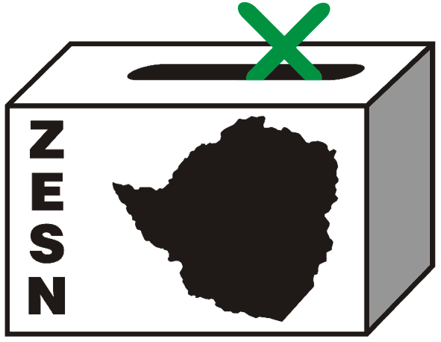

PRESS STATEMENT

Timing for By-Elections Inappropriate- ZESN

Harare – 24 October 2008 – The Zimbabwe Election Support Network (ZESN) notes with serious concern the announcement by the Zimbabwe Electoral Commission that it will proceed with preparations for the holding of by-elections despite a clause in the agreement between ZANU-PF and the two MDC formations not to contest each other should vacancies arise in the House of Assembly and Senate.

While elections are the tenets to any democracy, the timing for holding the by-elections is not appropriate. Cognisant of the gross politically - motivated violence and human rights violations that took place in the run up and post June 27 run-off election, ZESN strongly believes that people are still traumatised. Furthermore the ordeals of violence have left societies dehumanised and have engendered feelings of hatred and polarisation within the country. The murder, assault, abduction and displacement of scores of people after the 29 March harmonised elections cannot be condoned. People’s homes, livestock, properties were torched to ashes, while some were left disabled. ZESN had one of its observers killed in Hurungwe North constituencies for observing the harmonised elections on 29 March 2008 and many other observers were harassed and victimised. Several ZEC officials were arrested and it is alleged that at least one ZEC official was abducted and murdered. The criminals who in most cases have been named and identified have neither been arrested nor prosecuted. On the contrary many of the victims are still facing false allegations of political violence and as such will not able to freely participate in any election process. The conditions are simply not conducive for the conduct of a free and fair by-election in any part of the country.

It is against this backdrop that ZESN is gravely concerned about the timing of these by-elections as the economic and socio-political environment as well as the legal framework governing elections is not conducive for the holding of any election in the immediate future. This therefore calls for the need for national healing, cohesion and depolarisation of the society which is also recognised in the Memorandum of Understanding (MOU), in which parties involved had agreed that for a period of 12 months there will be no by-elections owing to the fact that the country was not ready for another election. Article XXI, clause 21.1 states that ……should any electoral vacancy arise in respect of a local authority or parliamentary seat, for whatever reason, only the party holding that seat prior to the vacancy occurring shall be entitled to nominate and field a candidate to fill the seat…….. .

Recognising that the holding of the by-elections is in accordance with the laws governing elections in Zimbabwe, and that the people have a fundamental right to elect representatives of their choice, it is ZESN’s considered view that the MOU rightfully acknowledged the need to give the people a 12 month period for some breathing space and national healing.

ZESN further notes the urgency for the following measures before any election in any constituency is held:-

- Fundamental reforms to restore the bill of rights and restore basic freedoms both in the statute book and in actual practice;
- Practical measures to end lawlessness, repression, persecution of government critics, human rights activists and human rights defenders;
- Fundamental electoral reforms to redress existing flaws and ensure a level playing field;
- The establishment of an independent, accountable and transparent electoral management body;
- A credible electoral process;
- Transparency in postal voting and tabulation of results;
- Restoration of the independence and professionalism of all institutions of government namely the Police, the Army, Civil Service, Attorney General’s Office and the Judiciary.

In as much as ZESN supports the holding of elections, the Network adamantly encourages a democratic and transparent process where fundamental human rights such as freedom of association, movement, expression and campaigning are recognised. The electorate should also be provided with comprehensive voter education and information. Political parties are strongly discouraged from harassing and intimidating voters, engaging in vote buying, misusing of state resources among other malpractices.

ZESN therefore re-emphasises on the need to inculcate a culture of political tolerance, respect and fair political contest. A transparent, independent and accountable electoral management that fosters credible elections.

Values and practices of political tolerance, respect, non-violence and dialogue are the only means of resolving political differences before any election takes place. End//

Background

There are three vacant seats in the House of Assembly, Gokwe-Gumunyu resulting from the death of ZANU PF’s Mr. Ephraim Mushoriwa, Matobo North seat vacated by MDC’s Mr. Lovemore Moyo (elected Speaker of Parliament) and Guruve North resulting from the death of ZANU PF’s Mr. Cletus Mabharanga. There are also three vacant constituency seats in the Senate, Chegutu seat vacated by Mrs.Edna Madzongwe (elected President of Senate), Chiredzi seat vacated by Mr. Titus Maluleke (ZANU PF) on appointment as Provincial Governor of Masvingo and Gokwe South vacated by Mr. Jaison Max Kokerai Machaya (ZANU PF) on appointment as Provincial Governor, Midlands.

PROMOTING DEMOCRATIC ELECTIONS IN ZIMBABWE

FOR COMMENTS AND FURTHER DETAILS CONTACT
Zimbabwe Election Support Network
+263 (04) 250735/6 or 703956 zesn@africaonline.co.zw / info@zen.org.zw or visit www.zesn.org.zw

