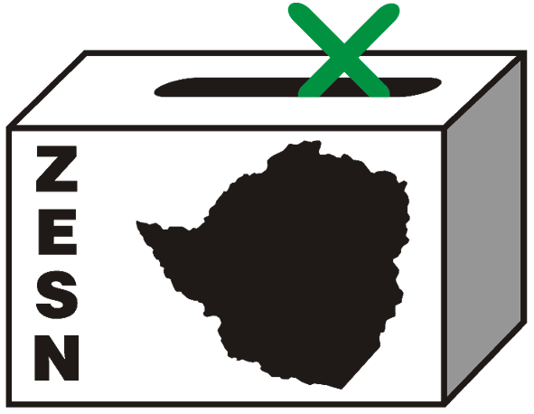
ZESN WILL NOT OBSERVE THE 27 JUNE RUN OFF
Harare – 24 June 2008 – The Zimbabwe Election Support Network (ZESN), a network of 38 organisations will not be observing the 27 June election due to the following reasons;
- The Minister of Justice, Legal and Parliamentary Affairs, Mr. Patrick Chinamasa has reduced the number of ZESN observers from 8 667 observers that it fielded during the 29 March harmonized election to 500 for the run-off. On 2 June 2008, ZESN submitted its first list of 11122 and a supplementary list of 4311 names on 12 June 2008. On 19 June 2008 ZESN received a letter from the Minister of Justice, Legal and Parliamentary Affairs to reduce its number of observers from the two lists (15433) to 500. ZESN re-submitted the 500 names on Friday 20 June 2008. The suggestion that domestic election observation personnel, if not reduced, would disrupt the smooth running of the electoral process is absurd. The electoral legal framework as stipulated in Statutory Instrument 21 of 2005, second schedule section 19 (2) and (3) clearly allows up to 3 static domestic observers per polling station per observer group and one per observer group at constituency tabulation centre. The reduction in the number of ZESN observers by Mr. Patrick Chinamasa reduces transparency and undermines democracy. Given the prescribed numbers the law allows, Zimbabwe’s electoral process can actually accommodate in excess of 27 000 domestic observers stationed within the country’s 9 231 polling stations across the country. At an observers briefing held on 23 June 2008, ZEC announced that as of Sunday 22 June 2008, they had only accredited 84 local observers.

- ZESN has also raised concerns over the re-issuing of new invitations for the run- off yet other procedures and laws for the two elections remained the same. As of today 24 June 2008, ZESN had not received the invitation of its 500 observers submitted on 20 June 2008. Given the fact that there are only two days left before the election, it is therefore neither practical nor possible for the organisation to communicate with its observers to come to the central accreditation centres in Harare and Bulawayo. The processes of training, accreditation and deployment of the observers cannot be conducted in the short space of time left before polling.

- ZESN’s observers for the 29 March harmonised elections have been subjected to severe attacks which have left Elliot Machipisa an observer from Hurungwe dead, 30 beaten and over 200 displaced, 14 had their homes and property destroyed. These are the only reported cases as hundreds of other displaced and brutalized observers went unreported. Although the above-mentioned cases have been reported to the police together with names of perpetrators, no action has been taken by the law enforcement agents. Furthermore, ZESN offices and its National Director’s house were raided on 25 April 2008 by police allegedly looking for subversive material. Allegations which are vehemently denied by ZESN.

It is against this backdrop that ZESN is gravely concerned about the safety of its observers given the deliberate targeting of the same. ZESN notes with great concern that these are blatant and deliberate attempts to ensure that domestic election observers do not play any meaningful role in the proposed June 27th run-off. This is in violation of the SADC Principles and Guidelines Governing Democratic elections.
Given the above facts, ZESN is unable to fulfill its mandate to effectively observe the run off.
ZESN therefore calls for the respect of local observers’ rights and unfettered access in the electoral process that fosters transparency and credibility. In future elections, accreditation of observers should be done within a reasonable period that allows for the observation of the pre-election period and that accreditation should be decentralized to districts.
Furthermore the network calls for the invitation and accreditation of local observers and all electoral administration roles to be done by a single electoral management body that is impartial, non-partisan and independent.

PROMOTING DEMOCRATIC ELECTIONS IN ZIMBABWE
FOR COMMENTS AND FURTHER DETAILS CONTACT
Zimbabwe Election Support Network
+263 (04) 250735/6 or 703956 zesn@africaonline.co.zw / info@zesn.org.zw or visit www.zesn.org.zw

