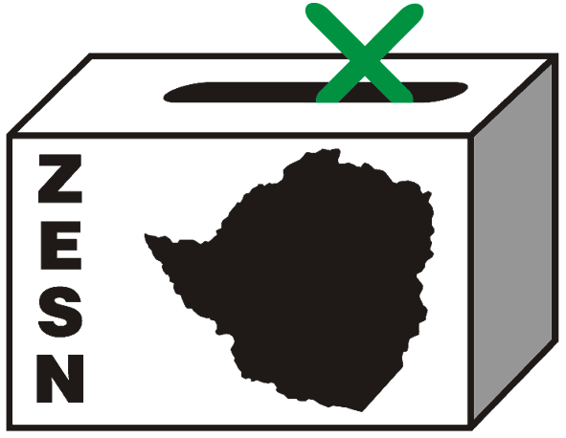

ZESN STATEMENT ON CONTINUED ATTACKS ON ITS OBSERVERS

Harare 16 May 2008 - The Zimbabwe Election Support Network a non-partisan, independent group of 38 non-governmental organisations strongly condemns the alarming escalation of post election violence specifically targeting its observers.

ZESN observers have been under siege from suspected ZANU PF supporters in various parts of the country. Observers have been abducted, severely assaulted and injured, sometimes requiring hospitalisation. In another distressing incident, where observers had sought medical treatment at Mt Darwin hospital, nurses were assaulted for assisting victims of political violence, forcing observers to flee the hospital, fearing for their own lives.

Some ZESN observers have been subjected to harassment and intimidation while homesteads and property have been destroyed. Some homesteads were looted targeting clothing and food reserves. Hundreds of observers have been displaced while some have been reduced to hiding in the woods for days before making their way to seek refuge in Harare and other places.

To date, at least 30 observers have been provided with shelter through the Network while 155 have reported to be staying with friends and relatives. We believe that a lot more have been affected and have not been able to communicate with the Network.

As an institution, the Network has also been the recipient of heightened attention from the police and security forces. The ZESN Chairperson, National Director and Programmes Manager have been detained and questioned on several occasions by the police. Questioning focussed on ZESN’s election monitoring and observation of the ongoing 2008 harmonized elections; the Network’s projections of the Presidential results as well as financial and other issues. On the 25th of April the organisation’s offices and the National Director’s home was searched by police officers from the Law and Order section of the Criminal Investigation Department. A number of files and documents were seized from both premises.

Various allegations against the organisation have been made by some sections of the media including pronouncements by senior government officials that ZESN is a pro-MDC organisation that was used to bribe ZEC officials during the 29 March 2008 harmonised elections as well as campaigning for the opposition under the guise of voter education. These allegations are unfounded and seem to be calculated efforts bent on discrediting and intimidating ZESN before the runoff.

In observing this and previous elections, ZESN has not broken any of the laws of Zimbabwe. It has been duly invited and accredited and has conducted its electoral observation efforts in accordance with regional and international standards. ZESN’s mission remains promoting participatory democracy in Zimbabwe.

ZESN reiterates that it will not be deterred from continuing to carry out its mandate of observing the prevailing environment, the presidential runoff election and the post election period, providing information, encouraging citizen’s participation and advocating for a conducive environment for the holding of credible elections.

Background
ZESN intensively observed the harmonised election held on 29 March 2008, providing the people of Zimbabwe with an objective, alternative source of reliable election related information. The observation included the deployment of 8667 accredited observers. Based on official vote counts publicly displayed at polling stations as required by the Electoral Act, ZESN collected data from a representative random sample of 435 polling stations spread across all 10 provinces and after a careful and thorough analysis of the data meeting the highest statistical standards, accurately projected the presidential election results of 29 March 2008. (See www.zesn.org.zw.) Ends//

PROMOTING DEMOCRATIC ELECTIONS
For commends and further details contact
Zimbabwe Election Support Network (ZESN)
+263 (04)250735/6 703956 zesn@africaonline.co.zw or info@zesn.org.zw

