ZIMBABWE ELECTION SUPPORT NETWORK (ZESN)
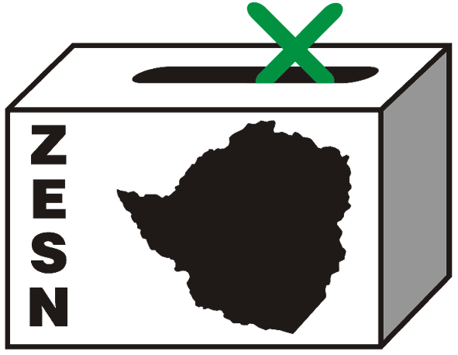

ZESN VEHICLE CONFISTICATED BY ZANU PF SUPPORTERS IN KOTWA

FOR IMMEDIATE RELEASE

Harare 13 May 2008 – A vehicle belonging to the Zimbabwe Electoral Support Network (ZESN) has been confiscated by ZANU PF supporters at Kotwa Centre, in Mudzi. The vehicle, a Toyota land cruiser had been deployed by ZESN to go and rescue three of its observers who had been seriously beaten by suspected ZANU PF supporters and needed urgent medical assistance.

The ZESN driver and officer who had the vehicle reported that they were stopped by the ZANU PF supporters who were in an unregistered red Mitsubishi open truck in Mudzi and were asked to explain the purpose of their visit in the area. After 6 hours of questioning, the ZANU PF supporters searched the vehicle and found the driver’s delivery book which showed deliveries that had been done to various partners and members. The two ZESN staff members were then subsequently detained at around 1000hrs at the ZANU PF offices in Kotwa under the guard of three ZANU PF youths. Around 0230hrs, one of the ZANU PF youths guarding the two assisted them to escape fearing for their lives.

ZESN is distressed by the continued reports of observers being victimised and assaulted in the aftermath of the 29 March 2008 harmonised elections.

ZESN would like to remind all political parties in Zimbabwe, in particular ZANU PF, the police, the Zimbabwe Electoral Commission and the general public that in observing this and previous elections, ZESN has broken no Zimbabwean law and has conducted its electoral observation efforts in accordance with the laws of the country including recognised regional and international standards.

As such, the organization calls the responsible authorities to ensure the apprehension of perpetrators of violence. ZESN urges the police to launch a massive campaign that protects observers, party agents and supporters of any political party. Political leaders should continue making public pronouncements against any forms of violence regardless of the perpetrator’s affiliation.

PROMOTING DEMOCRATIC ELECTIONS

FOR COMMENTS AND FURTHER DETAILS CONTACT
ZIMBABWE ELECTION SUPPORT NETWOK
+263 (04) 250735/6 703956 zesn@africaonline.co.zw/ info@zesn.org.zw

