ZIMBABWE ELECTION SUPPORT NETWORK (ZESN)
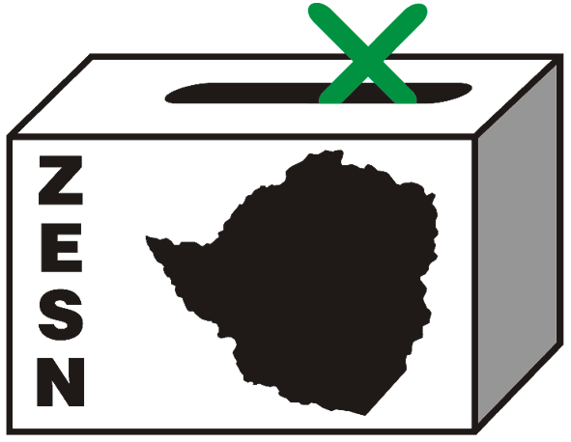

ZESN calls for the respect for the rights of non-partisan independent election observers as well as the will of the people of Zimbabwe.

Harare 2 May 2008 – Since the Zimbabwe Electoral Support Network (ZESN) announced projections for the presidential election on 31 March 2008, its members, staff, management and leadership has been subject to a campaign of intimidation by the government. These projections clearly show Morgan Tsvangirai secured more votes than Robert Gabriel Mugabe.

In observing this and previous elections, ZESN has broken no Zimbabwean law and has conducted its electoral observation efforts in accordance with regional and international standards. As such, the organization has been accredited by the relevant body for every election since inception 2000. For the 29 March 2008 harmonised elections, the Minister of Justice, Parliamentary and Legal Affairs approved ZESN accreditation of 11 808 observers and 8 667 observers were duly accredited by the Zimbabwe Electoral Commission (ZEC). Further, all ZESN observers received training and signed a code of conduct and which abide them to conduct themselves in a non-partisan manner.

Despite this, some ZESN observers have been beaten, one had his home torched, some have been harassed and intimidated. The ZESN National Director, Rindai Chipfunde-Vava was detained for 45 minutes at the Harare International Airport on the 15th of April 2008. ZESN's national offices were also raided by the police on 25 April 2008. Armed with a search warrant allowing them to look for subversive material, the police confiscated a number of ZESN's documents and took its Programs Manager, Tsungai Kokerai, who was subsequently detained at Harare Central Police Station for 6 hours by the police for questioning. The home of ZESN's National Director, was also raided by the police on the 25th of April. ZESN's Chairperson, Noel Kututwa and Chipfunde-Vava have been required for three days running to make themselves available at Harare Central Police Station to answer questions and furnish the police with statement explaining a number of issues.

ZESN’s mission remains to promote democratic elections in Zimbabwe and this can only be done by helping ensure that the country's political problems are resolved through the ballot box rather than by the barrel of the gun. “We believe all of these efforts are intended to intimidate ZESN so that it will not observe future elections. ZESN will not be moved by these cynical actions on the part of the government and will continue to defend the right of Zimbabweans to vote. A right so dearly paid for in the struggle for the country’s liberation”, says Kututwa.

It has now been one month since the elections and confidence in the ZEC long since begun to wane. At a minimum the ZEC needs to release immediately polling station level vote counts along with overall results for the presidential election for there to be any confidence in their accuracy. Even this may no longer be sufficient. "For the good of the nation, the government should accept the will of the people. This will enable the country to move beyond its political crisis and begin to address the economic and social problems facing the country," reiterates Kututwa.

Presidential Poll Projections – 29 March 2008 Harmonized Elections
Candidate | Projected Percent  Vote | Margin of  Error | 95% Confidence Interval
Makoni, Herbert Stanley Simba | 8.2% | ± 1.1% | 7.1 to 9.3
Mugabe, Robert Gabriel | 41.8% | ± 2.6% | 39.2 to 44.4
Towungana, Langton | 0.6% | ± 0.1% | 0.5 to 0.7
Tsvangirai, Morgan | 49.4% | ± 2.4% | 47.0 to 51.8

PROMOTING DEMOCRATIC ELECTIONS

FOR COMMENTS AND FURTHER DETAILS CONTACT
ZIMBABWE ELECTION SUPPORT NETWOK
+263 (04) 250735/6 703956 zesn@africaonline.co.zw/ info@zesn.org.zw

