ZIMBABWE ELECTION SUPPORT NETWORK (ZESN)
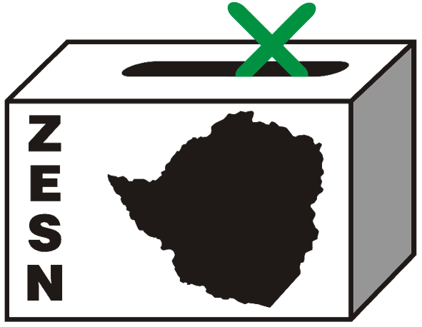

Statement on the Announcement of Presidential Results and Presidential Run-Off

2 May 2008 – Presidential results announced

The Zimbabwe Election Support Network (ZESN), a network of 38 non-governmental organisations, which has been observing all aspects of the electoral process of the 29 March 2008 harmonized elections notes the announcement of the result of the Presidential poll by the Zimbabwe Electoral Commission (ZEC) in which the ZANU PF candidate, Robert Mugabe garnered 43.2%, the MDC (Tsvangirai) candidate Morgan Tsvangirai got 47.9%, Simba Makoni got 8.3% and Langton Towungana got 0.6% of the vote.

“This is a clear circumstance that will necessitate an electoral run off in terms of Section 110 of the Electoral Act, we urge the ZEC to ensure that said run-off is undertaken within 21 days as is outlined by the Electoral Act. The law provides that ‘where two or more candidates are nominated and no candidate receives a majority of the total number of valid votes cast, a second election” must be held within 21 days after the previous election”, explains Noel Kututwa Chairperson of ZESN.

ZESN will continue to play its role in the observation of this election and the provision of independent information to all stakeholders. The organisation will continue the deployment of its long-term observers (LTOs) and short-term observers (STOs) across the country. The Network cautions that duly accredited observers should be allowed to freely continue observing the election process. ZESN will keeping a close watch on the situation and calls on the responsible authorities to guarantee the security of observers. ZESN also call on ZEC to ensure the invitation and accreditation of all local and international groups accredited to observe the 29 March poll is extended to cover this second round.

In the run-up to the second round of the presidential poll, ZESN re-emphasises on the need for Zimbabwe to adhere to and implement minimum conditions set out in Southern African Development Community (SADC) Principles and Guidelines Governing Democratic Elections in this re-run and all subsequent elections.

ZESN calls for zero tolerance on the prevailing political violence. We call upon political leader to denounce political violence publicly. Furthermore ZESN urges the police to act swiftly and decisively in dealing with the perpetrators in accordance with the law. It is essential that the conditions prevailing prior to the 29 March poll should serve as minimum requirements for this election. ZESN particularly discourages any changes to the electoral legal framework through the use of the Presidential Powers (Temporary Measures) legislation or any other instrument. While ZESN is encouraged that improvements were noted in the elections of 29 March 2008 (of note less incidents of more extreme violence), the network urges all Zimbabweans to maintain the same spirit. Commendable reforms, particular the posting of results outside polling stations and constituency tabulation centres should not be eroded.

While noting the improvements preceding the 29 March poll, the Network urges ZEC and other relevant bodies to continue to make advances by availing and publicising information on noted areas of concern like the numbers and distribution of postal ballots, the number of registered voters per constituency, locations of tabulation centres, list of polling stations and exact details of procedures such as the verification and tabulation of results as well as the flow of information from the polling station to the national level. This should be done well in advance of Election Day and should not be subject to last minute changes. In addition the tabulation and collation of results should be done transparently, in the presence of partly agents and observers. Results should also be released in a timely, transparent and accountable manner as this will definitely help reduce tensions following any election.

Any election presents citizens with the opportunity to take the destiny of their nation into their hands. ZESN therefore urges all Zimbabweans who are registered to vote to come out in their numbers and exercise that democratic right freely. ZESN also urges the authorities to respect the will of the people of Zimbabwe.

The results announced are as follows:

Presidential Poll Results – 29 March 2008 Harmonized Elections
Candidate | Number of Votes | Projected Percent  Vote
Makoni, Herbert Stanley Simba | 207 470 | 8.3%
Mugabe, Robert Gabriel | 1 079 730 | 43.2%
Towungana, Langton | 14 503 | 0.6%
Tsvangirai, Morgan | 1 195 562 | 47.9%
Total Valid Votes | 2 497 265 | 100%
Spoilt ballots | 39 975
Total votes cast | 2 537 240
Percentage Poll |  | 42.7%

PROMOTING DEMOCRATIC ELECTIONS IN ZIMBABWE

FOR COMMENTS AND FURTHER DETAILS CONTACT
Zimbabwe Election Support Network

+263 (04) 250735/6 or 703956 zesn@africaonline.co.zw / info@zesn.org.zw or visit www.zesn.org.zw

