ZIMBABWE ELECTION SUPPORT NETWORK (ZESN)
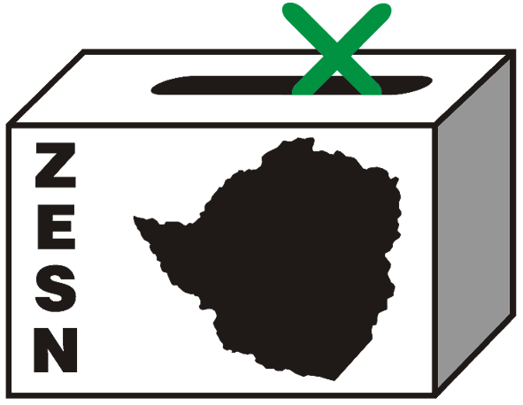

POLICE REQUEST ZESN CHAIRPERSON AND DIRECTOR TO SUBMIT DOCUMENTS

Alert Harare 29 April 2008 – Today the Chairperson and the Director of ZESN presented themselves to the Police officers from the Law and Order section in compliance with their request.

The two were questioned extensively specifically on ZESN’s election monitoring and observation of the ongoing 2008 harmonized elections. Particular focus was on the Network’s projections of the Presidential results. Police further requested written statements and supporting documents from the two explaining their duties and roles, ZESN’s relationship with ZEC before, during and after the election, ZESN’s relationship with the National Democratic Institute (NDI), ZESN financial statements and vouchers, actual number of ZESN’s accredited observers, list of ZESN members, list of ZESN funding partners amongst a plethora of other things. These will be submitted at 8.30 tomorrow morning at Harare Central police station.

PROMOTING DEMOCRATIC ELECTIONS

FOR COMMENTS AND FURTHER DETAILS CONTACT
ZIMBABWE ELECTION SUPPORT NETWOK
+263 (04) 250735/6 703956 zesn@africaonline.co.zw/ info@zesn.org.zw

