ZIMBABWE ELECTION SUPPORT NETWORK (ZESN)
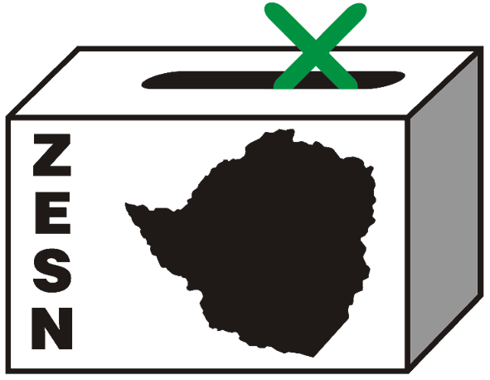

ZESN OBSERVES VOTE RECOUNT

Harare 29 April 2008 – Recounting started on Saturday 19 April, despite MDC Tsvangirai’s efforts to block the recounting through litigation. It is depressing to note that this exercise is taking place before the initial presidential results are announced and remain shrouded in secrecy and controversy in spite of calls from various stakeholders including ZESN to have the results released. Recounts have however been completed in all constituencies.

The Zimbabwe Election Support Network (ZESN), deployed 70 observers in all constituencies where recounting of votes was taking place. ZESN observers reported that opening of votes recounting started with major hiccups in most centres. For instance in Lupane recounting started as late as 1830hrs. In Gutu counting started at 0950hrs, while in Masvingo Central and Masvingo West by 1000hrs polling officials were still identifying and sorting ballot boxes. ZESN noted that some the delays were caused by disputes between polling officials and MDC party agents who alleged that ballot boxes had been tampered with.

In Chimanimani West and Buhera South recounting started at 1230hrs and 1245 respectively. In Chimanimani West the delay was a result of a protracted discussion as to the procedures to be followed during the recounting process. While in Buhera South, ZESN observers reported that some of the polling officials did not turn up for work and hence recounting could not commence on time.

A disturbing report of inconsistencies was received from ZESN observers deployed in Chiredzi North. The observers reported that in a total of 4 polling stations, a total of 184 ballots are unaccounted for. Such inconsistencies have been noted on ballot boxes from Ndari, Mutapurwa, Ruware and Chikwirire polling stations. In the most appalling discrepancy observed at Ruware Primary School Polling Station where, the number of voters whose names were cancelled in the voters’ roll was 351 and the number of voters that used voters’ slips was 92. However the number of ballots cast and found in the House of Assembly box was 606. A shortfall of 163 votes could not be accounted for and the Presiding Officer was questioned on the differences. There were no postal ballots for the polling station concerned.

Still in Chiredzi North, ZESN also notes with concern that at Chigonono Polling station the Presiding Officer reported that ballots for the Senate and House of Assembly had ran out on polling day resulting in more ballots being cast for the Local Government and Presidential elections. Accordingly, no communication was made to the Constituency Command Centres and voting is reported to have continued, disenfranchising numerous would be voters in the House of Assembly and Senate election. Other inconsistencies identified during the recount in Chiredzi North include the discovery of 7 Senate ballots in the House of Assembly Box and another 7 House of Assembly ballots found in the Senate box.

In the case of Manyaya Polling station in Chiredzi North and in Zvimba North, the process of recounting was partially disturbed by the absence of V11 forms with no full explanation from the Presiding Officer. The Presiding Officer for Chigonono Polling Station in the constituency together with his staff did not turn up for the recount.

In Bikita West, counting continued with its fair share of drama with three confirmed arrests of Presiding Officers for Domboshava, Bikita Clinic and Chikukutu Polling Stations. ZESN observers also reported that, in Mutare West while the recount did not affect the result of the House of Assembly, the recount has resulted in the MDC Presidential candidate loosing 67 votes while the ZANU PF candidate gaining 99 votes. There were variances in the results that were posted by ZEC after the 29 March elections and the results of recount. For an instance, in Gutu South MDC Tsvangirai, gained 141 votes while MDC Mutambara gained 147. Had the contest been very close such discrepancies could have resulted in the turn of the results.

It is with great concern that ZESN notes mix ups of ballot papers, inconsistencies and differences in figures as well as arrests of polling officials though some of these did not necessarily disadvantage any candidate. It however raises a lot of questions about the training capacity, competence and integrity of the polling officials in effectively running elections in a truly transparent and independent manner.

ZESN is however disturbed by reports of violence, political retribution, intimidation that have marred the nation. The network urges people of Zimbabwe to remain calm and calls all political leaders to publicly denounce all forms of violence.

PROMOTING DEMOCRATIC ELECTIONS

FOR COMMENTS AND FURTHER DETAILS CONTACT
ZIMBABWE ELECTION SUPPORT NETWOK
+263 (04) 250735/6 703956 zesn@africaonline.co.zw/ info@zesn.org.zw

