ZIMBABWE ELECTION SUPPORT NETWORK (ZESN)
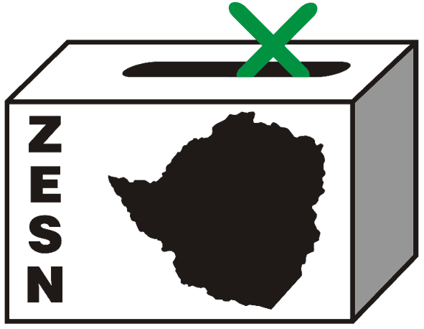

POLICE REQUESTS TO SEE ZESN DIRECTOR

Harare 29 April 2008 – Police officers from the Law and Order section have requested to see the ZESN National Director, Ms Rindai Chipfunde Vava today at 1000hrs. This follows the search and seizure of documents of the organisation’s offices and the Director’s house on the 25th of April during which the police also asked to see the both the Chairperson and the Director. Subsequently ZESN Chair Noel Kututwa on behalf of ZESN handed himself to the police yesterday. The police then requested Mr Kututwa to submit, ZESN financial accounts, banking accounts, a written description of ZESN activities as well as an explanation on the role of ZESN in the 29 March elections.

ZESN will continue to monitor the situation and will continuously update its members, the general public, the regional and the international community on the fate of Ms Rindai Chipfunde Vava.

PROMOTING DEMOCRATIC ELECTIONS

FOR COMMENTS AND FURTHER DETAILS CONTACT
ZIMBABWE ELECTION SUPPORT NETWOK
+263 (04) 250735/6 703956 zesn@africaonline.co.zw/ info@zesn.org.zw

