ZIMBABWE ELECTION SUPPORT NETWORK (ZESN)
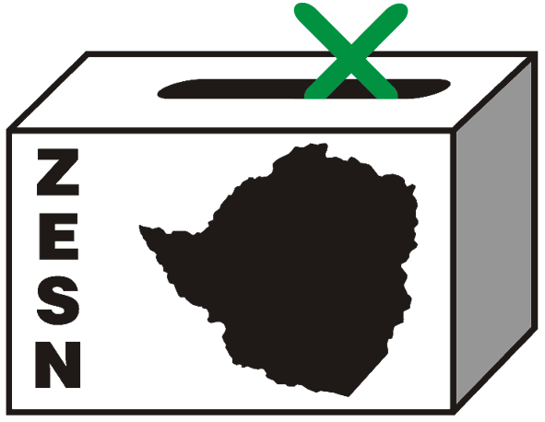

ZESN CHAIRPERSON HANDS HIMSELF TO THE POLICE

Harare 28 April 2008 – The ZESN Chairperson Noel Kututwa has handed himself to the police today. This follows the search and seizure of documents of the organisation’s offices and the National Director, Rindai Chipfunde Vava’s house on the 25th of April by police officers from the Law and Order section. They had a search warrant which authorised them to look for subversive materials that could be used to overthrow a constitutionally elected government. A number of files and documents were seized from the office and the Director’s house subsequent upon which they asked for the Chairperson and the Director to report to Harare Central Police Station.

ZESN strongly condemns this police action as intimidation, harassment and in particular the seizure of ZESN’s documents. ZESN would like to re-assure its members and the general public that this police action will not deter ZESN from carrying out its mandate of observing the election and will continue to do so.

ZESN will continue to monitor the situation and will continuously update the general public, the regional and the international community on the fate of Mr Kuktutwa.

ZESN re-emphasise its call for the release of the presidential results forthwith. Further delays will undermine the electoral process and will further erode the public’s confidence in the electoral process as well as the results themselves.

PROMOTING DEMOCRATIC ELECTIONS

FOR COMMENTS AND FURTHER DETAILS CONTACT
ZIMBABWE ELECTION SUPPORT NETWOK
+263 (04) 250735/6 703956 zesn@africaonline.co.zw/ info@zesn.org.zw

