ZIMBABWE ELECTION SUPPORT NETWORK (ZESN)
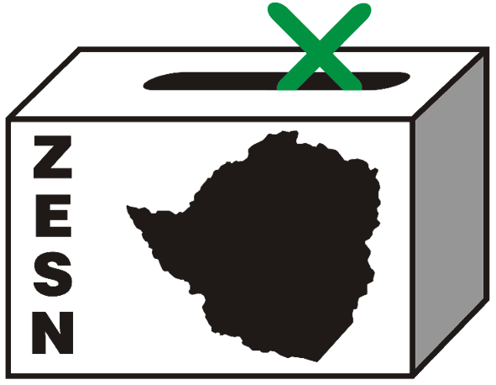

ZESN URGES ZEC TO RELEASE PRESIDENTIAL ELECTION RESULTS FORTHWITH

Harare 2 April 2008 – The Zimbabwe Election Support Network (ZESN), a group of 38 leading Zimbabwe civil society organizations urges the Zimbabwe Electoral Commission to immediately release the Presidential results as the delays are now causing anxiety and speculations that are detrimental to the maintenance of peace and tranquillity.

The continued delay by ZEC to announce the official Presidential result, might lead to suspicions of vote manipulation. It is in the best interest of ZEC, the electorate, political parties, party agents, observers, candidates and all other stakeholders for the Presidential official results to be made public forthwith. Most importantly the continued delay in releasing the results undermines the credibility and transparency of the electoral process.

ZESN notes that there were inconsistencies in the application of the legal requirement to post results outside polling stations and constituency centres. ZESN observers noted that by 1 April 2008 results were not posted in Zvimba North, Zvimba West and Makonde constituency tabulation centres.

ZEC should therefore forthwith release the results and issue out a public explanation on the delay and the irregularities mentioned above. ZESN will continue to observe the electoral process through its conclusion and issue additional statements and updates as appropriate. Ends//

PROMOTING DEMOCRATIC ELECTIONS

FOR COMMENTS AND FURTHER DETAILS CONTACT
ZIMBABWE ELECTION SUPPORT NETWOK
+263 (04) 250735/6 703956 zesn@africaonline.co.zw/ info@zesn.org.zw

