ZIMBABWE ELECTION SUPPORT NETWORK (ZESN)
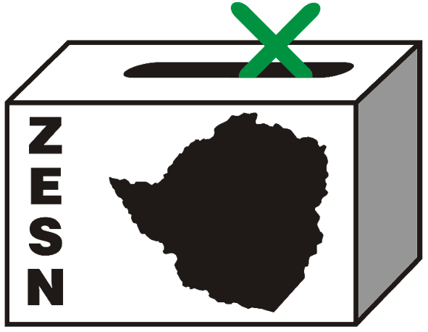

ZESN POLL PROJECTIONS ON MARCH 29 PRESIDENTIAL ELECTIONS

Harare 31 March 2008 – The Zimbabwe Election Support Network (ZESN), a group of 38 leading Zimbabwe civil society organizations announced today the findings of an electoral observation effort using information gathered by accredited observers from a random representative sample of polling stations in all provinces of the country. This technique, known as Sample Based Observation (SBO), is a proven methodology used worldwide to build confidence in the electoral process. It has been used in over 20 countries including Zambia, Madagascar and Malawi.

In order to give the people of Zimbabwe confidence in the conduct of the tabulation process and the degree to which the Zimbabwe Electoral Commission (ZEC) results reflect the will of the people, trained and accredited ZESN observers collected official vote counts from a representative random sample of polling stations across the ten provinces of the country. The sample is stratified by province and urban/rural areas to ensure that the findings are representative. An independent statistician reviewed the exercise to ensure it meets the highest statistical standards.

While it is the responsibility of the Zimbabwe Electoral Commission (ZEC) to announce the official results of the election, it is the legal duty of election observers to provide the people of Zimbabwe with independent non-partisan information on all aspects of the electoral process. This information helps build confidence in the process. Based on official vote counts publicly displayed at polling stations as required by the Electoral Act, ZESN collected data from a representative random sample of 435 polling stations spread across all 10 provinces and after a careful and thorough analysis of the data, ZESN is able to make the following projections about the presidential elections:

- Morgan Tsvangirai is projected to receive the highest number of votes in the March 29, 2008 presidential election;
- Robert Gabriel Mugabe is projected to receive the second-highest number of votes; and,
- Herbert Stanley Simba Makoni is projected to receive the third-highest number of votes

The projections are follows:
Presidential Poll Projections – 29 March 2008 Harmonized Elections
Candidate | Projected Percent  Vote | Margin of  Error | 95% Confidence Interval
Makoni, Herbert Stanley Simba | 8.2% | 1.1% | 7.1 to 9.3
Mugabe, Robert Gabriel | 41.8% | 2.6% | 39.2 to 44.4
Towungana, Langton | 0.6% | 0.1% | 0.5 to 0.7
Tsvangirai, Morgan | 49.4% | 2.4% | 47.0 to 51.8

One of the most important changes in this election was the posting of vote counts at individual polling stations. We urge ZEC to immediately publish polling station results at the national level for all elections and the distribution of postal ballots. Publishing polling station level results will serve to enhance public confidence. ZESN will continue to observe the electoral process through its conclusion and issue additional statements as appropriate.

PROMOTING DEMOCRATIC ELECTIONS

FOR COMMENTS AND FURTHER DETAILS CONTACT
ZIMBABWE ELECTION SUPPORT NETWOK
+263 (04) 250735/6 703956 zesn@africaonline.co.zw/ info@zesn.org.zw

