ZIMBABWE ELECTION SUPPORT NETWORK (ZESN)

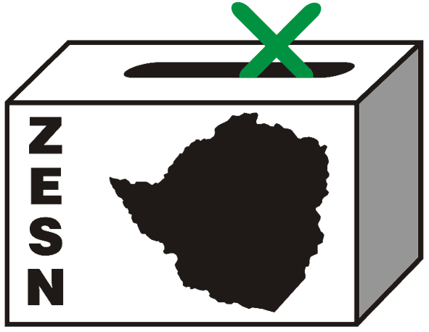

ZESN CALLS FOR TRANSPARENCY AND CALM DURING VOTE TABULATION AND ANNOUNCEMENT OF RESULTS

Harare - 30 March 2008 - The Zimbabwe Election Support Network (ZESN), a network of 38 independent, non-partisan non-governmental organisations, is observing all aspects of the 2008 harmonized electoral process held yesterday. Based on the observations of the entire process to date and using the Southern African Development Community (SADC) Principles and Guidelines Governing Democratic Elections as minimum conditions for the conduct of elections, ZESN shares with the people of Zimbabwe its initial findings and conclusions on the 29 March 2008 Harmonized Elections. ZESN will continue to observe the process and issue updates as appropriate.

Overall, while there have been improvements from past elections (for example fewer incidents of overt violence), the pre-election and campaign environment continues to affect adherence to the SADC Principles and Guidelines Governing Democratic Elections. In particular, concern remains about the lack of political tolerance, limited access to state media, and use of state resources. Other issues of concern include restrictive proof of residence, status of the voters’ roll, delayed and limited voter education and information, lack of transparency in postal voting and production and distribution of ballot papers. These problems have an impact on the conduct and outcome of the elections.

The following preliminary findings are based on reports from some of the 8000 ZESN accredited observers deployed across Zimbabwe. At this time, ZESN continues to receive reports from all over the country and a final statement will be issued upon receipt of all the reports.

Across Zimbabwe the opening of polling stations occurred largely without serious problems. From the reports received from polling stations, ZESN observers reported that 86% opened without any problem; 13% had minor problems and only 2% had major problems like shortage of voting materials that affected the rights of Zimbabweans to vote. Such shortages were observed at Gatche Gatche Polling station in Kariba which ran out of ballot papers twice. In Harare and some parts of the country some constituencies were affected by inadequate lighting.

The voting process generally took place without serious problems. However there were a number of polling stations where minor problems were reported, but these did not appear to affect the right of Zimbabweans to vote. ZESN observers also reported that at some polling stations eligible voters with identification documents were not permitted to vote. According to reports, voting at 71% polling stations went without any problems; at 26% minor problems occurred and at just 3% there were major problems. The major problems were voters going to the wrong ward, wrong identification documents, and the issue of renunciation of foreign citizenship. According to ZESN observers the closing of polling stations and the counting process largely took place without problems.

ZESN encourages the ZEC to conduct the tabulation of election results as quickly as possible. The announcement of results in a timely, transparent and accountable manner helps reduce tensions following any election. It is important to underline that this process is not over. ZESN will continue to observe this process and will issue additional statements and updates as appropriate. We urge ZEC to carry out its duties in an impartial, orderly and transparent manner.

We are confident that our approach is responsible. We urge all contestants in the process to remain calm and act responsibly in the best interests of Zimbabwe, peace and democracy.
Ends//

If you would like more information about this issue, or schedule an interview with Noel Kututwa (ZESN Chairperson) please call on 0912 233 640. You can also arrange for an interview with the ZESN National Director Rindai Chipfunde-Vava. To arrange for a meeting with her please call Rindai at 04-790934 / 799421, 011 415 902 or e-mail rindai@zesn.org.zw or zesn@africaonline.co.zw

Zimbabwe Election Support Network (ZESN)
Promoting democratic elections in Zimbabwe

The Zimbabwe Election Support Network (ZESN) is a coalition of 38 non-governmental organizations. The mission of ZESN is to promote democratic elections in Zimbabwe. One of the most important objectives of ZESN are to effectively gather, disseminate and communicate objective information about elections and other democratic processes as well as to promote democratic free and fair electoral processes through objectively and impartially monitoring and observing elections.

