Zimbabwe Election Support Network (ZESN)
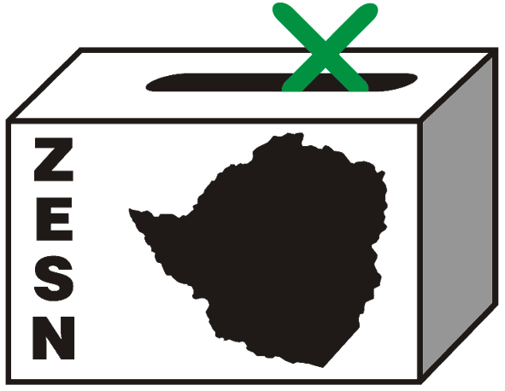

PRESS RELEASE

For Immediate Release

ZESN READY FOR THE 2008 HARMONIZED ELECTIONS

28 March 2008 - Harare – The Zimbabwe Election Support Network has completed its preparations to observe the 29 March 29 2008 Harmonized elections. ZESN has recruited and trained 8 000 short-term observers who will be deployed throughout the country, to observe the setting up of polling stations, voting, counting and tabulation procedures. All ZESN observers have been accredited by the Zimbabwe Electoral Commission (ZEC) and signed a ZESN Code of Conduct obliging them to observe elections in a non-partisan manner.

Noel Kututwa, ZESN Chairperson, was quoted as saying “ZESN will have more than 8,000 observers at polling stations across the country to defend the rights of Zimbabweans to vote. ZESN encourages all registered-voters to turn out and cast their ballot for the candidate and party of their choice.”

ZESN uses the Southern African Development Community (SADC) Principles and Guidelines Governing Democratic Elections as a baseline. This document sets out minimum conditions for the conduct of elections in the region. ZESN members have monitored all stages of the pre-election period including the nomination procedures, updating of the voters’ roll, media and campaigning. Based on the observations of its 210 long term observers who have been deployed since December 2007, ZESN has issued six election updates which provided the information on the pre-election period (available at www.zesn.org.zw). At the moment, ZESN is compiling its findings, conclusion and recommendations about the pre-election period.

ZESN observes elections in order:

- To give a sense of confidence and security to the electorate and the public during the election period.
- To encourage voter turnout
- To deter electoral fraud
- To establish whether electoral laws are clearly defined and meet basic SADC standards
- To establish whether these laws are understood by election officials, political contestants and the public and are not manipulated by any of the stakeholders
- To assist in the development of adequate electoral laws through electoral reform.

ZESN encourages all Zimbabweans who are eligible to vote to go out in their numbers and exercise their democratic right to select candidates and parties of their choice. ZESN observers will be out at polling stations on election day to defend the rights of Zimbabweans to vote.

If you would like more information about this issue, or schedule an interview with Noel Kututwa (ZESN Chairperson) please call on 0912 233 640. You can also arrange for an interview with the ZESN National Director Rindai Chipfunde-Vava. To arrange for a meeting with her please call Rindai at 04-790934 / 799421, 011 415 902 or e-mail rindai@zesn.org.zw or zesn@africaonline.co.zw

Zimbabwe Election Support Network (ZESN)
Promoting democratic elections in Zimbabwe

The Zimbabwe Election Support Network (ZESN) is a coalition of 38 non-governmental organizations. The mission of ZESN is to promote democratic elections in Zimbabwe. One of the most important objectives of ZESN are to effectively gather, disseminate and communicate objective information about elections and other democratic processes as well as to promote democratic free and fair electoral processes through objectively and impartially monitoring and observing elections.

